
COMPUTER SCIENCE DEPARTMENT

Total Marks: 7.5

Obtained Marks:

Project Report

Fundamentals of Programming

Personal Expense Tracker

Name : Kamil Abbas
Registraton No : 2580350
Submitted to: Sir Usama Irshad

Expense Tracker

- Introduction

The Personal Expense Tracker is a console-based application developed in C++ to assist users in managing their financial limits. By allowing users to set a predefined budget and log expenses, the system provides real-time feedback on spending habits. This project serves as a practical application of fundamental programming constructs such as loops, conditional branching, and arithmetic operations.

2. Problem Statement

Managing personal finances is often a challenge due to a lack of immediate visibility into spending versus a set limit. Without a tracking system, individuals frequently exceed their budgets. This software addresses the need for a simple, lightweight tool that calculates cumulative expenses and warns the user when they have surpassed their financial boundaries.

3. Aims and Objectives

To implement a menu-driven system for ease of navigation.
To utilize relational and logical operators to compare spending against a user-defined budget.
To demonstrate the use of nested loops and switch-case statements for complex program flow.
To provide categorized feedback (e.g., "High Spending" or "Over Budget") based on specific numerical thresholds.

4. Significance

This application is significant as it introduces the concept of Data Validation and Conditional Logic in software engineering. It bridges the gap between theoretical syntax and functional utility, providing a base that can later be expanded with file handling or graphical interfaces.

5. Design / Methodology

The program is designed using a modular logic approach within the main() function:
Initialization: Sets the budget and resets counters.
Menu Loop: A do-while loop ensures the program runs until the user explicitly exits.
Expense Logic: A while loop (nested within a switch-case) manages the entry of new amounts.
Conditionals: A series of if-else if blocks evaluate the budget status, while a nested if identifies high-spending patterns.

6. Flowchart:

START

Define Budget (Input)

Add Expense (Input Amount)

NONOOO

Check: New Total > Budget
YES

NO
Compare To Budget
Display: Over Budget / High Spending (Output Process)

END

Simplified Flowchart for Expense Tracker.

7. Tools Used:

Language: C++
Programming Concepts: * Data Types: int for menu choices and float for financial precision.
Control Structures: switch-case, do-while, and while loops.
Operators: Arithmetic (+), Relational (>, ==), and Logical (&&).
Environment: C++ Compiler (GCC/MinGW) and Microsoft Word for documentation.
7. Flowchart Description
Logic Flow:
Start: Input the initial budget.
Display Menu: Options to Add Expense, View Total, or Exit.
Choice 1 (Add): Enter the amount; the program adds it to the total.
Choice 2 (View): * Compare total to budget.
Display "Over Budget," "Exact," or "Within Budget."
Check if total > 500 to trigger the "High Spending" alert.
Choice 3 (Exit): End the loop and terminate the program.

8. Implementation:
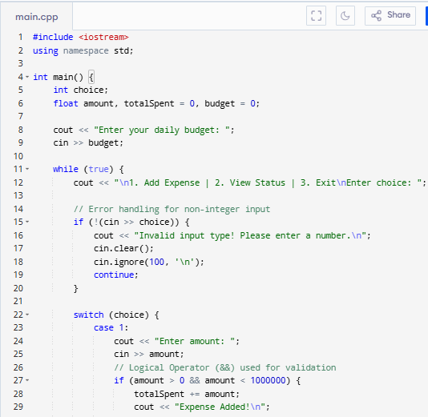
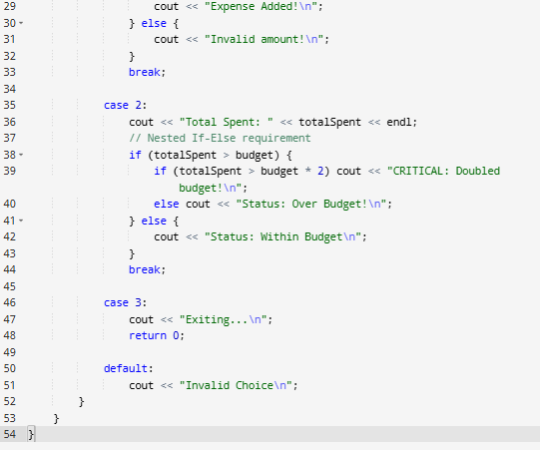

9. Result :

The implementation of the Personal Expense Tracker successfully achieved all functional requirements defined during the design phase.

System Performance: The program accurately captures user input for both budget and expenses. The use of the float data type ensures that financial decimals are handled correctly.

Logic Validation: The switch-case menu provides a seamless user experience, allowing for repetitive data entry without crashing.

Conditional Accuracy: The relational and logical operators (&&, >, ==) correctly identify when a user is "Within Budget," "Over Budget," or has reached "High Spending" thresholds (above 500).

User Feedback: The console output is clear, providing immediate visual confirmation of the total accumulated expenses after every entry

The result/output of the code in which the expense is within the budget or exceeding the budget is displayed below:

If the expense is within the budget:
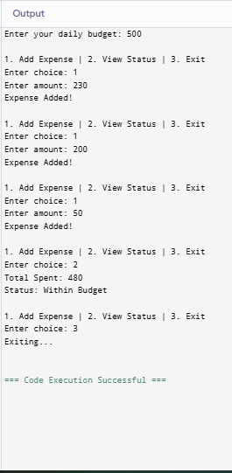

If the expense is exceeding the limit :
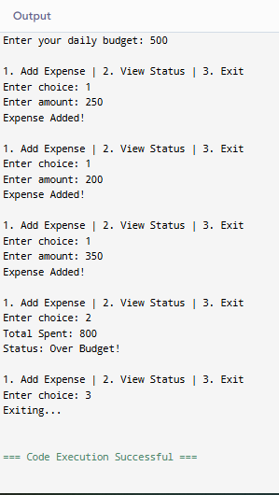

10. Conclusion:

The development of this Expense Tracker project has been a significant milestone in my introductory software engineering journey. By translating a real-world financial problem into C++ code, I have gained a deeper understanding of:

Control Flow: Mastering do-while and nested while loops to create a persistent application environment.

Conditional Logic: Using if-else structures and switch-cases to handle various user scenarios and data states.

Variable Management: Efficiently using int and float to manage memory and ensure mathematical precision.
Overall, the project successfully demonstrates the utility of software in simplifying daily personal tasks and improving financial management.

